**Bug Report**

* **Bug ID** – 1
* **Bug Summary** – Login functioning without data
* **Reporter** – Ani Urutyan
* **Submit Date** – 10.09.2023
* **Platform** – Acer
* **Operating system** – OS X 10.12.0
* **Browser** – Chrome 53
* **Severity** - Critical
* **Priority** – High
* **Status** – Open
* **Assigned to** – QA Head
* **Version** -1.0
* **Environment** – uat
* **Preconditions** – 1.Internet connection or Wi-Fi 2. Opened app https://qwallity-exam.onrender.com
* **Description** – User can login to the application without any username and password data.
* **Steps to reproduce** – 1.Login to the Qwallity app with secure “email” and “code”. 2. Leave blank "username" and "password" fields. 3. Click on "Log in" button.
* **Expected result** – The system should block account.
* **Actual result** – User can log In to his account without username and password.
* **References** – https://qwallity-exam.onrender.com/home
* **Bug ID** – 2
* **Bug Summary** – Double Notification
* **Reporter** – Ani Urutyan
* **Submit Date** – 10.09.2023
* **Platform** – Acer
* **Operating system** – OS X 10.12.0
* **Browser** – Chrome 53
* **Severity** - Low
* **Priority** – Medium
* **Status** – Open
* **Assigned to** – QA Head
* **Version** -1.0
* **Environment** – uat
* **Preconditions** – 1.Internet connection or Wi-Fi 2. Opened app https://qwallity-exam.onrender.com
* **Description** – When user is entering to the application, the notification “ You are now logged in” appears on the screen 2 times ( one after the other ).
* **Steps to reproduce** – 1.Login to the Qwallity app with secure “email” and “code”.2.Enter valid username and valid password. 3.Click on "Log in" button.
* **Expected result** – The system should appear one notification “ You are now logged in “.
* **Actual result** – The system appears more than one notification.
* **References** – <https://qwallity-exam.onrender.com/home>
* **Screenshot**

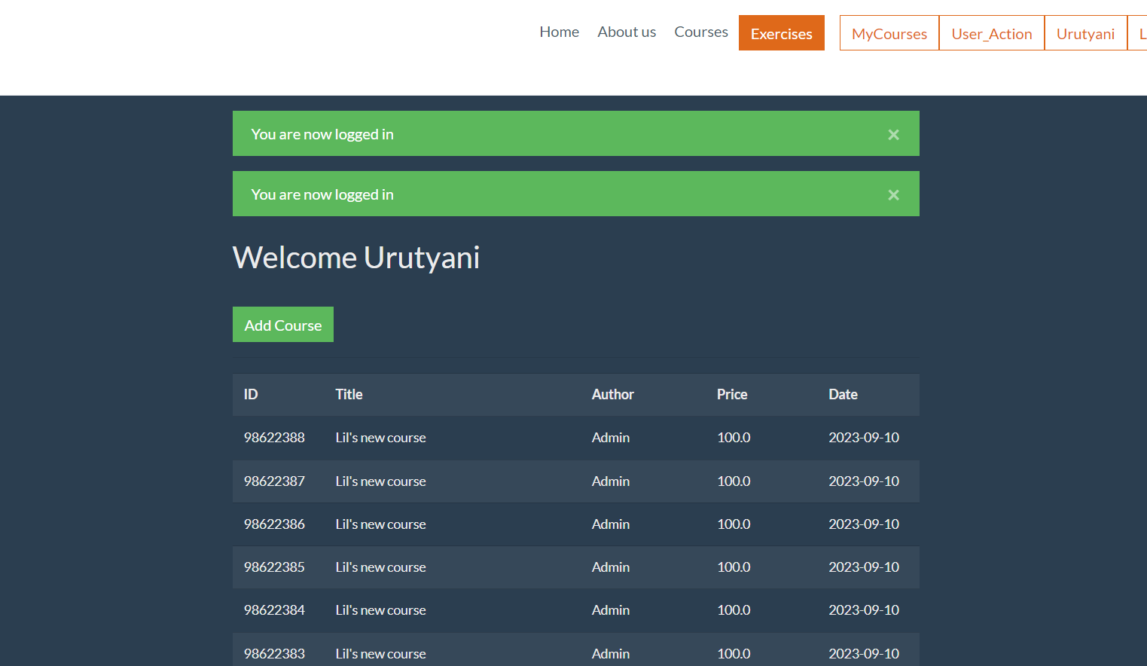

* **Bug ID** – 3
* **Bug Summary** – User profile button is modified and it is not functioning.
* **Reporter** – Ani Urutyan
* **Submit Date** – 10.09.2023
* **Platform** – Acer
* **Operating system** – OS X 10.12.0
* **Browser** – Chrome 53
* **Severity** - High
* **Priority** – Blocking
* **Status** – Open
* **Assigned to** – QA Head
* **Version** -1.0
* **Environment** – uat
* **Preconditions** – 1.Internet connection or Wi-Fi 2. Opened app https://qwallity-exam.onrender.com
* **Description** – User profile button has been modified and is not working (at the top right of the main page).
* **Steps to reproduce** – 1.Login to the Qwallity app with secure “email” and “code”.2.Enter valid username and valid password. 3.Log in to the application.
* **Expected result** – The button of user profile (Username) should be clickable , and work correctly.
* **Actual result** – User profile button is modified, is not working.
* **References** – <https://qwallity-exam.onrender.com/home>
* **Screenshot**

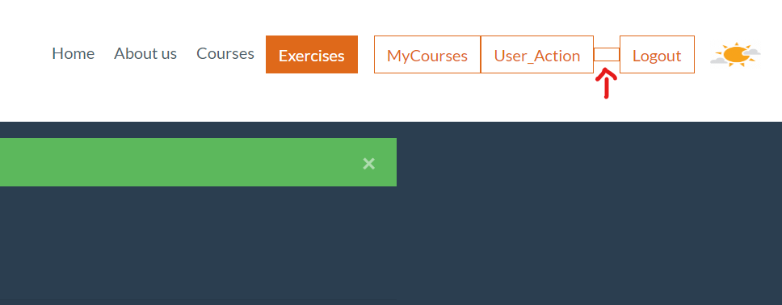

* **Bug ID** – 4
* **Bug Summary** – “Change discount” is running with empty fields.
* **Reporter** – Ani Urutyan
* **Submit Date** – 10.09.2023
* **Platform** – Acer
* **Operating system** – OS X 10.12.0
* **Browser** – Chrome 53
* **Severity** - Medium
* **Priority** – High
* **Status** – Open
* **Assigned to** – QA Head
* **Version** -1.0
* **Environment** – uat
* **Preconditions** – 1.Internet connection or Wi-Fi 2. Opened app https://qwallity-exam.onrender.com
* **Description** – When admin user leaves the “discount” and “course_count” blnak and click on “Change discount” button, appears the notification “Discount is changed”
* **Steps to reproduce** – 1.Login to the Qwallity app with secure “email” and “code”.2.Enter admin valid username and valid password. 3.Log in to the application. 4. Navigate to User_Action 4.Click on “Change discount”. 5. Leave the fields blank. 6.Click on “Change discount” button.
* **Expected result** – The application should gives a notification “"Invalid parameters" or " Discount can not be changed".
* **Actual result** – Notification is “Discount is changed”.
* **Screenshot**

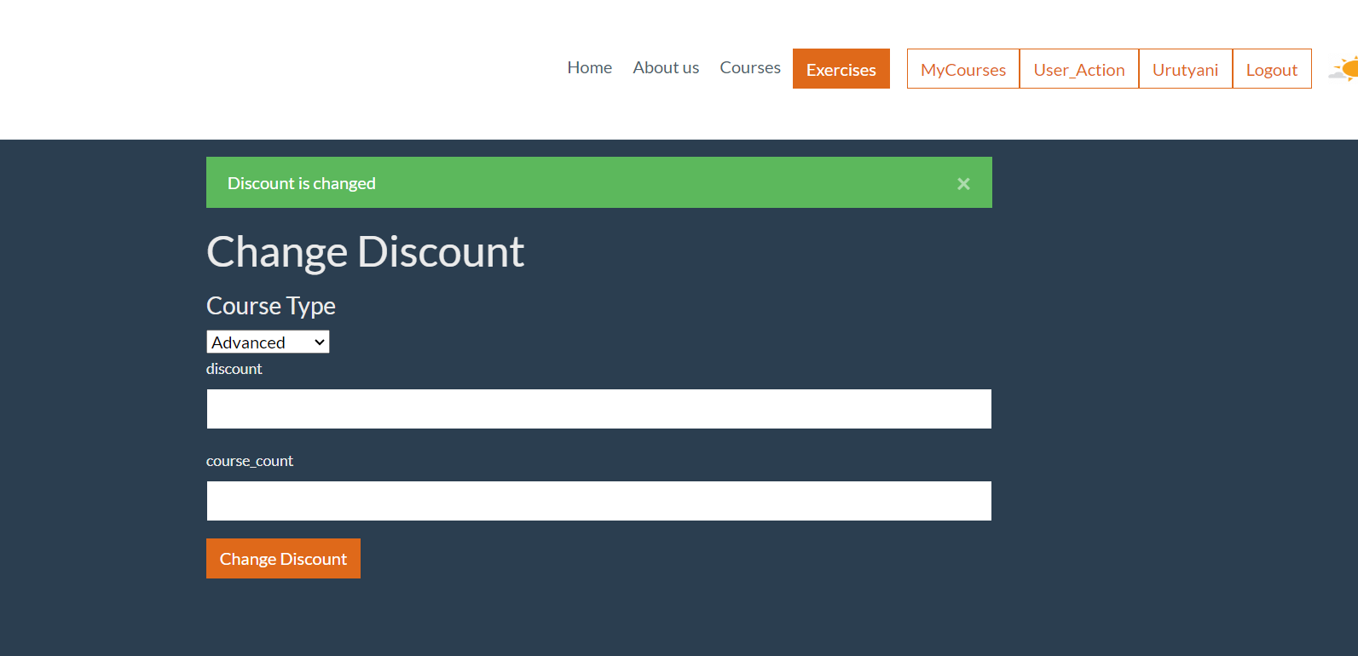

* **Bug ID** – 5
* **Bug Summary** – “Change discount” is running with invalid parameters.
* **Reporter** – Ani Urutyan
* **Submit Date** – 10.09.2023
* **Platform** – Acer
* **Operating system** – OS X 10.12.0
* **Browser** – Chrome 53
* **Severity** – High
* **Priority** – High
* **Status** – Open
* **Assigned to** – QA Head
* **Version** -1.0
* **Environment** – uat
* **Preconditions** – 1.Internet connection or Wi-Fi 2. Opened app https://qwallity-exam.onrender.com
* **Description** – When admin user puts non-numeric data in “discount” or “course_count” fields and click on “Change discount” button, appears the notification “Discount is changed”
* **Steps to reproduce** – 1.Login to the Qwallity app with secure “email” and “code”.2.Enter admin valid username and valid password. 3.Log in to the application. 4. Navigate to User_Action 5.Click on “Change discount”. 6. Input non-numeric values, symbols or letters in the fields “discount” or “course_count”. 7.Click on “Change discount” button.
* **Expected result** – The application should gives a notification “"Invalid parameters" or " Discount can not be changed".
* **Actual result** – Notification is “Discount is changed”.
* **Screenshot**

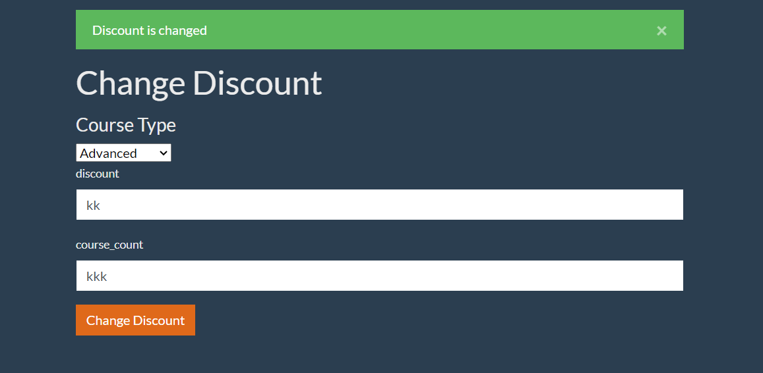

* **Bug ID** – 6
* **Bug Summary** – Wrong notification. System appers notification “Discount is changed” even if on the users account balance is insufficient.
* **Reporter** – Ani Urutyan
* **Submit Date** – 10.09.2023
* **Platform** – Acer
* **Operating system** – OS X 10.12.0
* **Browser** – Chrome 53
* **Severity** – High
* **Priority** – High
* **Status** – Open
* **Assigned to** – QA Head
* **Version** -1.0
* **Environment** – uat
* **Preconditions** – 1.Internet connection or Wi-Fi 2. Opened app <https://qwallity-exam.onrender.com>
* **Description** – When non-admin user has not enough money on his account balance and tries to buy a course, application appears the notifications “You have xxx discount. Discounted price is displayed” and after that “ Account balance insufficient”.
* **Steps to reproduce** – 1. Login to the Qwallity app with secure “email” and “code”. 2.Enter non-admin valid username and valid password. 3.Log in to the application. 4. Navigate to “Courses” 5.Click on “Funamental” or “Advanced” 6. Buy a course with insufficient balance.
* **Expected result** – The application should gives a notification “ Account balance insufficient”.
* **Actual result** – Notifications are “You have xxx discount. Discounted price is displayed” and “Account balance insufficient”.
* **Notes** – The discount has been changed before buying process.
* **Screenshot**

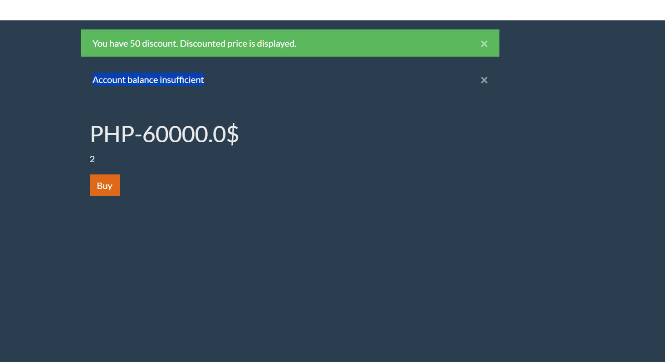

* **Bug ID** – 7
* **Bug Summary** – Inncorect notification about bought fundamental discounted course.
* **Reporter** – Ani Urutyan
* **Submit Date** – 10.09.2023
* **Platform** – Acer
* **Operating system** – OS X 10.12.0
* **Browser** – Chrome 53
* **Severity** - High
* **Priority** – High
* **Status** – Open
* **Assigned to** – QA Head
* **Version** -1.0
* **Environment** – uat
* **Preconditions** – 1.Internet connection or Wi-Fi 2. Opened app https://qwallity-exam.onrender.com
* **Description** – When non-admin user buy a course , the price should be shown already discounted and the system should appear the notification- ’You have xxx discount. Discounted price displays.’
* **Steps to reproduce** – 1.Login to the Qwallity app with secure “email” and “code”.2.Enter non-admin valid username and valid password. 3.Log in to the application. 4. Navigate to “Courses” 5.Select "Fundamental" section. 5.Click on the "Buy" button of one of the courses.
* **Expected result** – The price should be shown already discounted. Notification- ’You have xxx discount. Discounted price displays.’
* **Actual result** – There is notification- ’You have xxx discount. Discounted price is displayed.’ And discounted price is not appears.
* **Bug ID** – 8
* **Bug Summary** – Inncorect notification about bought discounted advanced course.
* **Reporter** – Ani Urutyan
* **Submit Date** – 10.09.2023
* **Platform** – Acer
* **Operating system** – OS X 10.12.0
* **Browser** – Chrome 53
* **Severity** - High
* **Priority** – High
* **Status** – Open
* **Assigned to** – QA Head
* **Version** -1.0
* **Environment** – uat
* **Preconditions** – 1.Internet connection or Wi-Fi 2. Opened app https://qwallity-exam.onrender.com
* **Description** – When non-admin user buy a course , the price should be shown already discounted and the system should appear the notification- ’You have xxx discount. Discounted price displays.’
* **Steps to reproduce** – 1.Login to the Qwallity app with secure “email” and “code”.2.Enter non-admin valid username and valid password. 3.Log in to the application. 4. Navigate to “Courses” 5.Select "Advanced" section. 5.Click on the "Buy" button of one of the courses
* **Expected result** – The price should be shown already discounted. Notification- ’You have xxx discount. Discounted price displays.’
* **Actual result** – There is notification- ’You have xxx discount. Discounted price is displayed.’ And discounted price is not appears.